**Exercise 4.a. – JavaScript**

**Name:** Badri MSV **Roll No:** 195002017

**Subject:** UIT1611 – Web Programming Lab **Faculty:** Dr. S. Sasirekha

**Date:**

**Aim:**

Write a Java Script that asks the user for a name, then greets the user with "Hello" followed by the username on the page based on time.

**Code:**

<html>

<head>

    <title>Greeting Message using JavaScript</title>

</head>

<body>

    <label id="lblGreetings"></label>

</body>

<script>

    let name = prompt("What is your name?");

    var myDate = new Date();

    var hrs = myDate.getHours();

    var greet;

    if (hrs < 12)

        greet = 'Good Morning';

    else if (hrs >= 12 && hrs <= 17)

        greet = 'Good Afternoon';

    else if (hrs >= 17 && hrs <= 24)

        greet = 'Good Evening';

    document.getElementById('lblGreetings').innerHTML =

        'Hello!! <b>'+ name + ' ' + greet + '</b>';

</script>

</html>

**Output:**

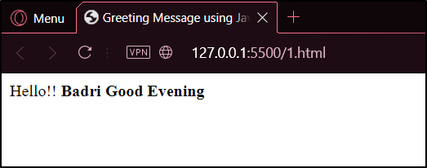

**Aim:**

Write a Java Script that collects the numbers from a page and then adds them up and prints them to a blank field on the page.

**Code:**

<!DOCTYPE html>

<html>

<head>

   <meta charset=utf-8 />

   <title>JS Bin</title>

   <style>

      body {

         padding-top: 50px

      }

   </style>

</head>

<body>

   <label for="text1">Enter Any Number:</label>

   <input type="text" id="text1"></input>

   <input type="button" id="button1" value="Add" onclick="add_element_to_array();"></input>

   <input type="button" id="button2" value="Display" onclick="display_array();"></input>

   <div id="Result"></div>

   <div id="sum"></div>

   <script>

      var x = 0, sum = 0;

      var array = Array();

      function add_element_to_array() {

         array[x] = document.getElementById("text1").value;

         sum += parseInt(document.getElementById("text1").value);

         alert("Element: " + array[x] + " Added at index " + x);

         x++;

         document.getElementById("text1").value = "";

      }

      function display_array() {

         var e = "<hr/>";

         for (var y = 0; y < array.length; y++) {

            e += "Element " + y + " = " + array[y] + "<br/>";

         }

         document.getElementById("Result").innerHTML = e;

         'sum is'

         document.getElementById("sum").innerHTML = sum;

      }

   </script>

</html>

**Output:**

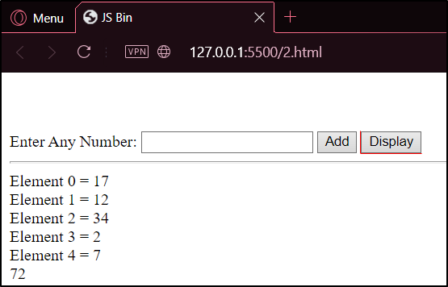

**Aim:**

Write a Java Script that prompts the user for a number and then counts them from 1 to that number displaying only the odd numbers.

**Code:**

<html>

<head>

    <title>Odd numbers</title>

</head>

<body>

    <label id="odd"></label>

</body>

<script>

    let num = prompt("Enter the number?");

    num = parseInt(num);

    var e = "<hr/>";

    for (let i = 1; i < num; i++) {

        if (i % 2 != 0) {

            e += + i + "</br>";

        }

    }

    document.getElementById('odd').innerHTML = '<b>' + e + '</b>';

</script>

</html>

**Output:**

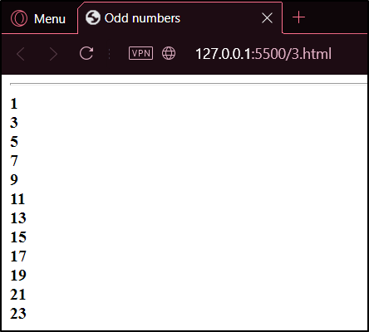

**Aim:**

Write a Java Script to create a form with labels and submit button to provide feedback/hint to the user. Ensure the field is not empty and have proper http:// else notify the user.

**Code:**

<!doctype html>

<html lang="en">

<head>

    <meta charset="utf-8">

    <title>JavaScript form validation - checking non-empty</title>

</head>

<body>

    <style>

        li {

            list-style-type: none;

            font-size: 16pt;

        }

        .mail {

            margin: auto;

            margin-top: 10%;

            padding-top: 10px;

            padding-bottom: 10px;

            width: 400px;

            background:

                #D8F1F8;

            border: 1px soild silver;

        }

        .mail h2 {

            margin-left: 38px;

        }

        input {

            font-size: 20pt;

        }

        input:focus,

        textarea:focus {

            background-color:

                lightyellow;

        }

        input submit {

            font-size: 12pt;

        }

        .rq {

            color:

                #FF0000;

            font-size: 10pt;

        }

    </style>

    <div class="mail">

        <h2>Input your Name and Submit</h2>

        <form name="form1" action="#" onsubmit="required()">

            <ul>

                <li><input type='text' name='text1' /></li>

                <li class="rq">*Required Field</li>

                <li><input type="submit" name="submit" value="Submit" /></li>

            </ul>

        </form>

    </div>

    <script>

        function required() {

            var empt = document.forms["form1"]["text1"].value;

            if (empt == "") {

                alert("Please input a Value");

                return false;

            }

            else {

                alert('Code has accepted : you can try another');

                return true;

            }

        }

    </script>

</body>

</html>

**Output:**

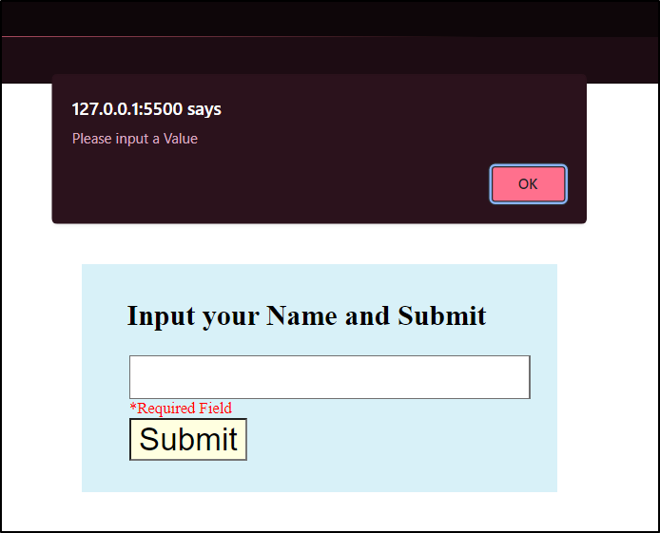 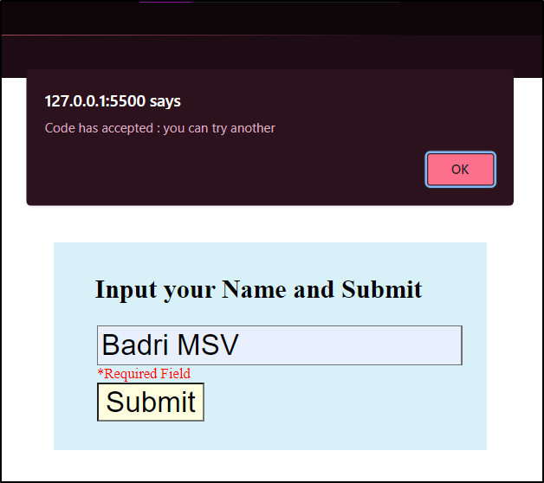

**Aim:**

Write a Java Script to create a number guessing game.

**Code:**

<html>

<head>

    <meta charset="utf-8">

    <title>Number Guessing Game</title>

    <style>

        html {

            font-family: sans-serif;

        }

        body {

            width: 50%;

            max-width: 800px;

            min-width: 480px;

            margin: 0 auto;

            margin-top: 10%;

        }

    </style>

</head>

<body>

    <h1>Guess The Number</h1>

    <p>We have selected a random number between 1 - 10.

        See if you can guess it.</p>

    <div class="form">

        <label for="guessField">Enter a guess: </label>

        <input type="text" id="guessField" class="guessField">

        <input type="submit" value="Submit guess" class="guessSubmit" id="submitguess">

    </div>

    <script type="text/javascript">

        // random value generated

        var y = Math.floor(Math.random() * 10 + 1);

        // counting the number of guesses

        // made for correct Guess

        var guess = 1;

        document.getElementById("submitguess").onclick = function () {

            // number guessed by user

            var x = document.getElementById("guessField").value;

            if (x == y) {

                alert("CONGRATULATIONS!!! YOU GUESSED IT RIGHT IN "

                    + guess + " GUESS ");

            }

            else if (x > y) /* if guessed number is greater

                   than actual number*/ {

                guess++;

                alert("OOPS SORRY!! TRY A SMALLER NUMBER");

            }

            else {

                guess++;

                alert("OOPS SORRY!! TRY A GREATER NUMBER")

            }

        }

    </script>

</body>

</html>

**Output:**

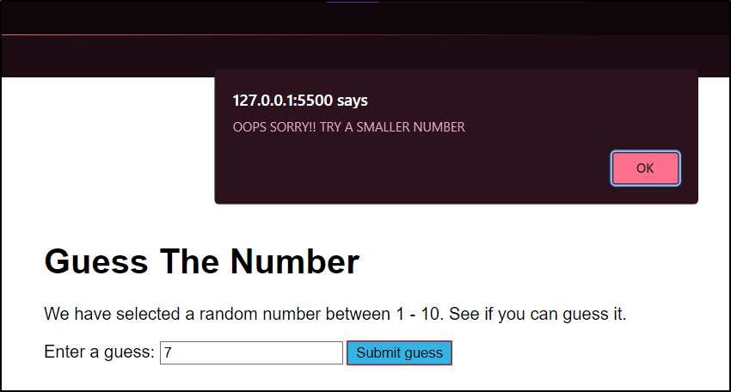

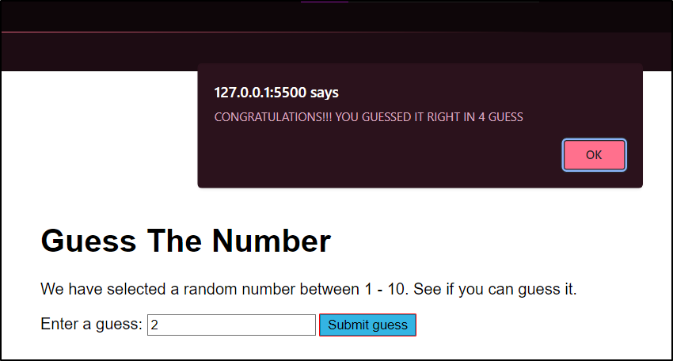

**Result:**

Thus, the JavaScript programs were written and executed successfully.